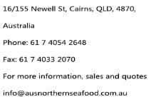

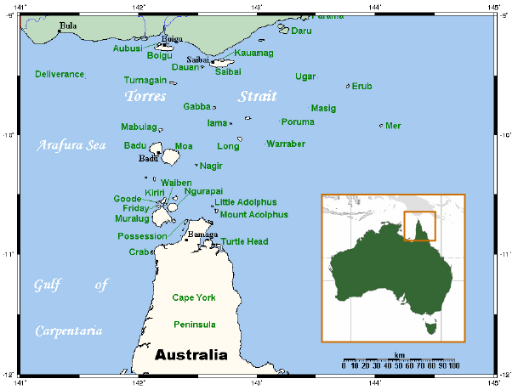
The region of Australia’s northern-most point is a place of immense natural beauty. Pure and untouched, its blue and crystal clear waters decorated with islands and coral reefs are home to Australia’s finest seafood. Our fleet is located in the waters of Torres Strait, an area that is declared a protected zone. It is strictly managed by the Protected Zone Joint Authority. Fishing in this area is prohibited by outsiders, except for a limited number of license holders. Our products are wild-caught and packed direct to you so you can taste the authentic flavours of northern Australian seafood.

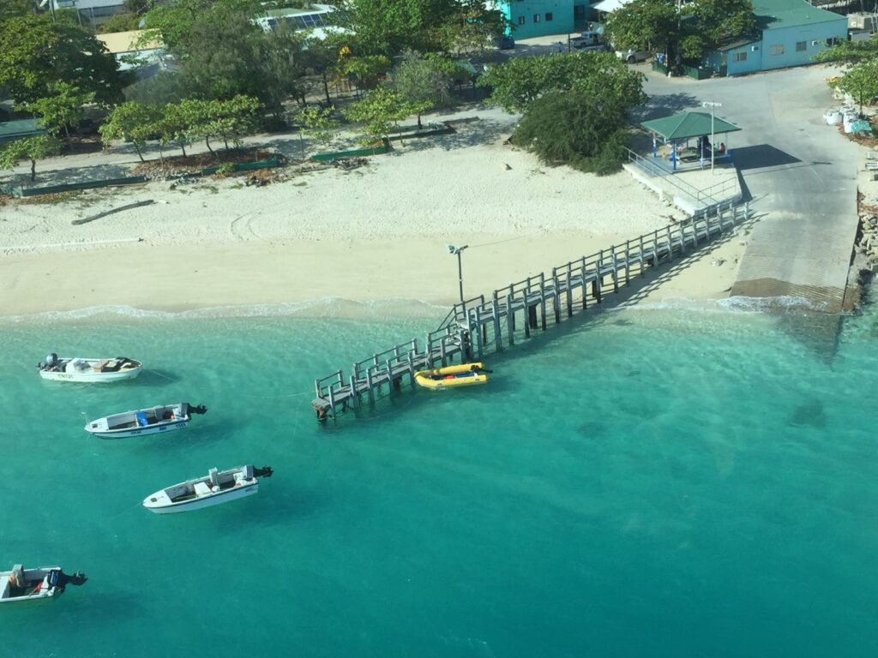
Our company is specialized in a range of lobster and seafood products from live to frozen. All our products are hand caught and produced to meet stringent AQIS export standards. We are proud to carry Australia’s reputation as the finest seafood producer in the world.

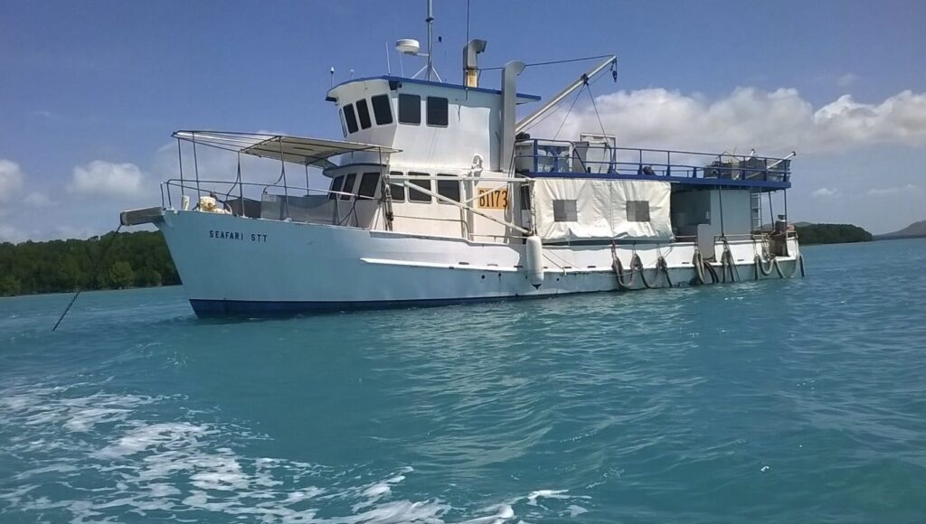

Experience is a pivotal part of our business. Our fleet has an experienced crew – some with 20 or more years of experience. This experience allows us to find the spots for the best catches of the season. We make sure our products are the highest of quality and that it reaches our customers tasting as fresh as nature intended it to be.

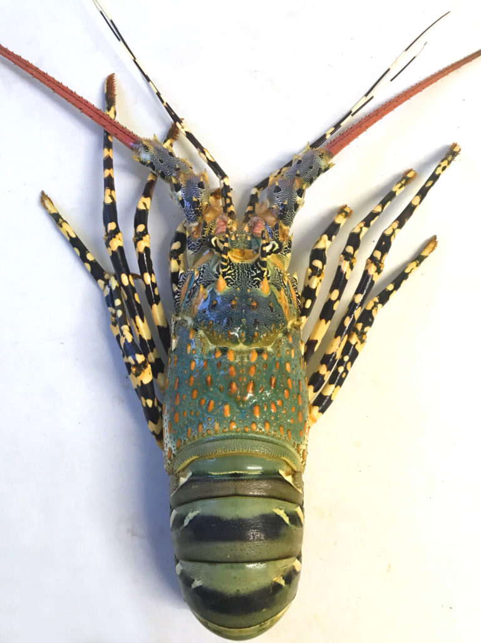

Scientific name: Panulirus Ornatus
Commercial names: Tropical Rock Lobster, Coral Crayfish, Rock Crayfish, Ornate lobsters, Painted lobsters, Scalloped lobsters.

Distribution:
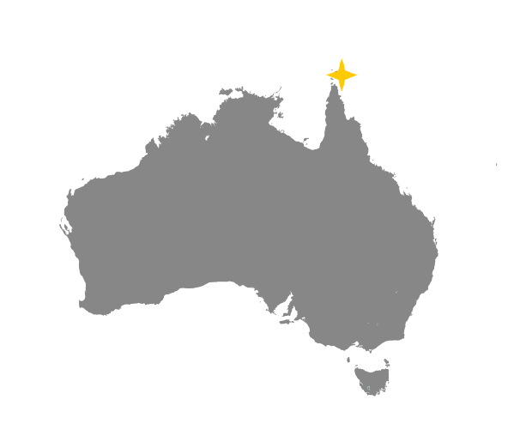
The Australian Tropical Rock Lobster is highly prized for its beautiful bright colours and delicious white meat. They dwell in the bottom of medium to shallow waters amongst coral reefs of north eastern Australia and in the Torres Straits of Australia’s northernmost point. Tropical Rock Lobsters are caught from December to September. From October to November lobster fishing is closed, allowing the lobster population to rejuvenate. Tropical Rock Lobsters rarely get into cages or take bait-traps so they can only be caught by hand in the wild by our divers.

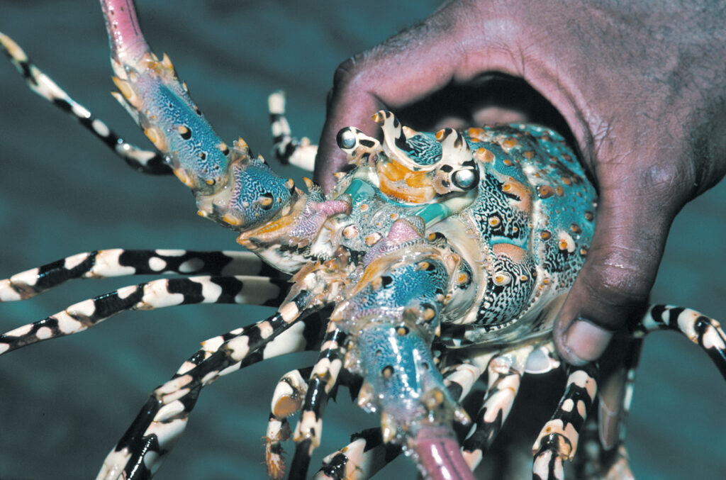
When raw, the shell is coloured from shades of Jade and black on the tail to turquoise and purple on the head. When cooked, the shell becomes an orange colour. With the taste, it is delicious whether it’s steamed, stir-fried or grilled. The lobster’s flesh is firm, with a sweet medium and rich taste; it retains its shape in most styles of cooking. While it’s raw, the flesh is translucent and tender, which is considered the best lobster for sashimi, plus the beautiful colours of the shells will surely wow diners.
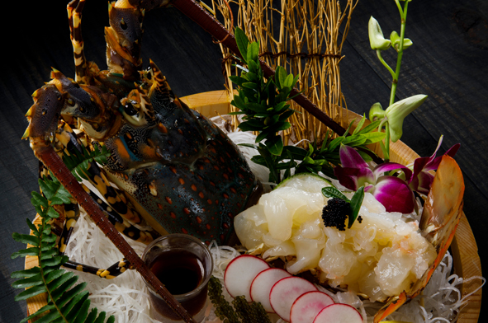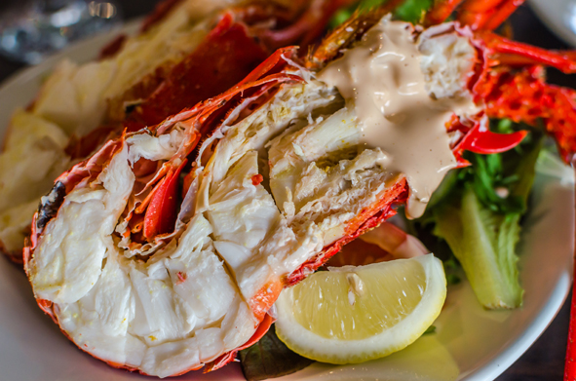
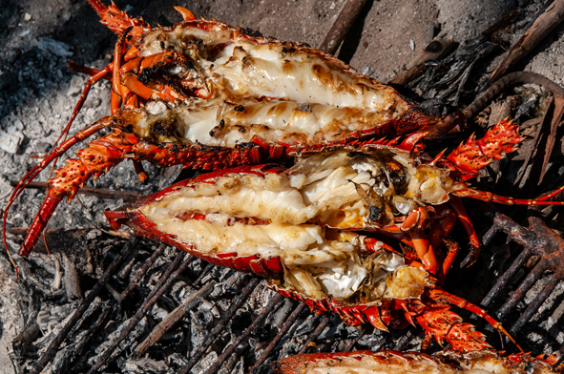

Live lobster grades
We grade our lobsters according to sizes. You can choose a grade that suited to your needs.
- 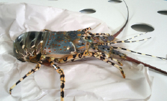

Frozen Tropical Lobster Products

Lobster products are snap frozen onboard our vessel’s processing facility after its caught . Our onboard snap freezers chill the product to minus 40 Celsius (- 40℃). This process maintains full texture, firmness and taste of the flesh when thawed. When seafood is caught, it loses its freshness with time, so the quicker its snap frozen, the more fresh it will be. As we freeze our product on our vessels, there’s no need to waste time taking the products to a land facility.
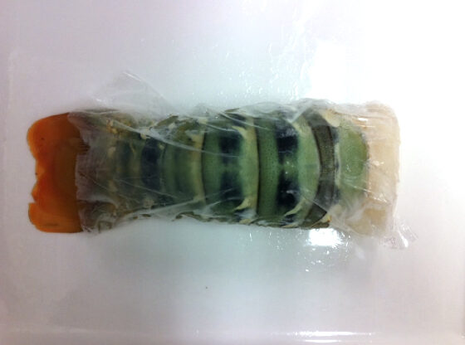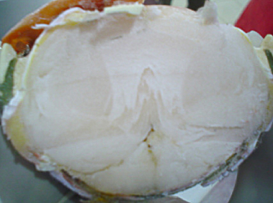

Live Lobsters
Our lobsters are stored in the state-of-the-art live holding tanks with patented world leading technology, which provides them with a most comfortable living condition to ensure they are healthy before shipping. Caring for the lobsters is very important to us, as we want to guarantee when the
